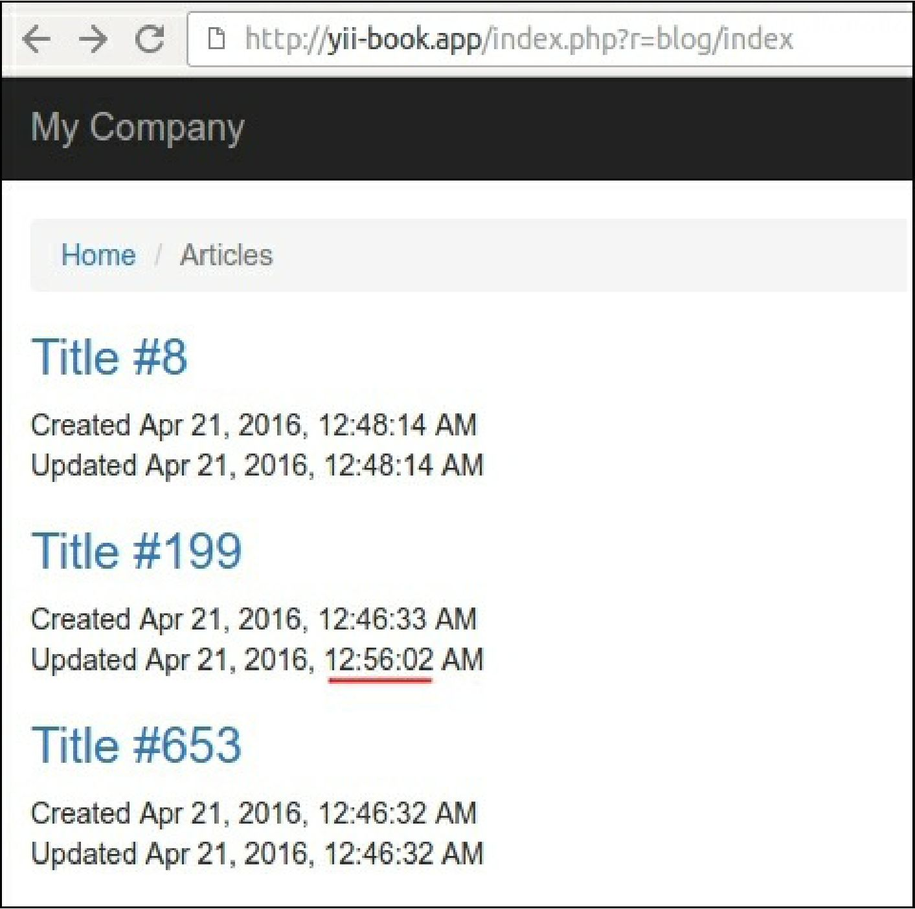

8. Open any page from our article, as follows: